Incident Response Report

Summary
- Severity: Medium
- Priority: P2
- Asset(s) Affected:
  - System Name: kingslanding
  - IP Address: 192.168.224.161
  - Software Affected:
    - PowerShell (C:\Windows\System32\WindowsPowerShell\v1.0\powershell.exe)
    - Windows Script Host (C:\Windows\System32\cscript.exe)

- Incident Owner: Sebastian Salas
- Contact Information: Sebasala@ensign.edu
- Incident Start Time: 2024-11-26 19:34:20.358 (UTC)
- Incident Close Time: Work in progress.

Incident Timeline
Incident Start Time (UtcTime):
- 2024-11-26 19:34:20.358
Log Capture Time (_timestamp):
- 2024-11-26T19:35:02.086Z
System Event Time (systemTime):
- 2024-11-26T19:34:20.363329900Z

Triage and Analysis

Incident Description:
On 2024-11-26, a suspicious PowerShell script was executed on a machine named kingslanding.sevenkingdoms.local. The script (d06deb_griffon_recon.vbs) was run via cscript.exe (a legitimate Windows tool), but it was executed in an unusual way using PowerShell with the -ExecutionPolicy Bypass flag. This method is often used in attacks to bypass security measures.

Detection:
- Method: The event was detected through Sysmon logs, which track system processes. It flagged a suspicious PowerShell execution (MITRE ATT&CK technique T1086).
- Alert: The rule that triggered the alert looked for abnormal PowerShell script executions like this one.

Immediate Actions Taken:
- Containment: The affected system was isolated from the network to stop potential spreading.
- Log Review: We reviewed the logs to understand the nature of the script and check for any malicious activity.
- Next Steps: We need to analyze the script further to confirm if it's malicious.

Questions for Investigation:
- Was the script execution authorized?
- What exactly does the script do?
- Were any other systems affected?

Indicators of Compromise (IOCs):
- File Hashes:
  - SHA1: 0E3C0779D8EAAD3B00363D7890DDC8272B510D49
  - MD5: A45586B3A5A291516CD10EF4FD3EE768
  - SHA256: 59D3CDC7D51FA34C6B27B8B04EA17992955466EB25022B7BD64880AB35DF0BBC
- Command Line:
  - "C:\\Windows\\system32\\cscript.exe" d06deb_griffon_recon.vbs

Scope and Impact:
- Scope: The issue seems to be limited to one machine for now.
- Impact: If this is part of an attack, it could lead to data theft, malware installation, or further attacks on other systems.

Supporting Evidence:
Logs showing the suspicious command execution, including the use of PowerShell and cscript.exe:

"CommandLine": "\"C:\\Windows\\system32\\cscript.exe\" d06deb_griffon_recon.vbs"

"ParentCommandLine": "powershell.exe -ExecutionPolicy Bypass -C \"cscript \\\"d06deb_griffon_recon.vbs\\\"\"”

Screenshots:

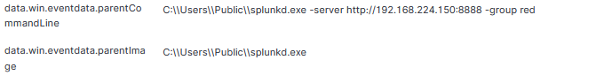
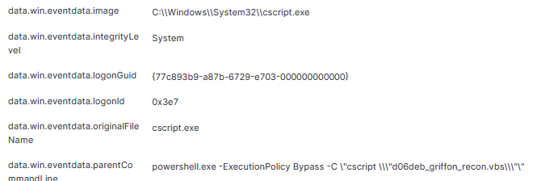

Containment and Neutralization (Short-term/Triage)
- Isolate the Affected System:
  - Disconnect the affected machine from the network.
  - Disable remote access (e.g., RDP).
- Stop Malicious Processes:
  - End the cscript.exe and any related PowerShell processes.
- Preserve Evidence:
  - Save memory dumps and logs for analysis.
  - Back up important files, including the malicious script.
- Check Other Systems:
  - Look at logs on other systems for similar activity.
- Temporary Measures to Prevent Further Damage:
  - Restrict or monitor PowerShell usage.
  - Block suspicious IP addresses in the firewall.
  - Ensure security software is updated.

Recovery and Vulnerability Remediation
- Recovery Steps:
  - Restore affected systems from backup.
  - Run antivirus scans to remove threats.
  - Ensure all systems are updated with the latest patches before reconnecting them.
- Vulnerability and Patching:
  - Scan for vulnerabilities and missing patches.
  - Apply critical updates and fix security issues.
  - Strengthen security settings on affected systems.
- Communication:
  - Update internal teams (IT, management) about the incident.
  - Notify external vendors or authorities if needed.
  - Keep stakeholders informed on recovery progress.

Hardening and Detection Improvements (Lessons Learned, Long-term Response)
- Long-term Mitigation and Preventive Measures:
  - Implement stronger access controls (e.g., multi-factor authentication).
  - Regularly update and patch all systems to prevent future vulnerabilities.
  - Conduct security awareness training for employees to prevent social engineering attacks.
  - Improve network segmentation to limit the impact of future incidents.
- Improvements to Detection Systems and Processes:
  - Enhance monitoring systems to detect unusual activity more quickly.
  - Update and fine-tune SIEM (Security Information and Event Management) rules.
  - Conduct regular security audits and penetration testing.
  - Set up automatic alerts for specific attack patterns or behavior anomalies.

